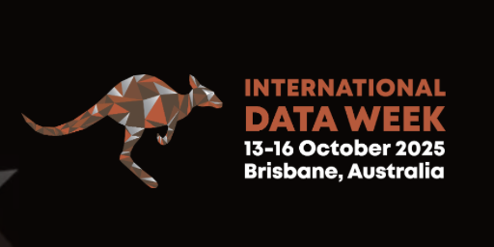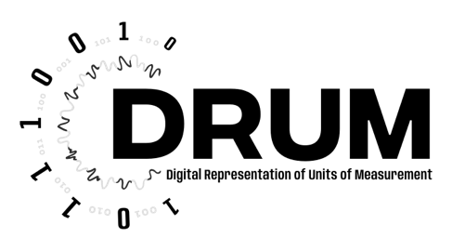

Units, Symbols and Terminology for Data Driven Science: Philosophy to Pragmatism

P5 (Brisbane Convention & Exhibition Centre)
SciDataCon Brisbane Tuesday 14th October 2025

Session Outline
What is a quantity, what do we (as Chemists, Physicist, Scientists in general, Social Scientists, Economists etc) mean by a quantity and what information needs to be provided to ensure that the associated measurement or prediction quantity is appropriately explained in a way that the value is useful.
This SciDataCon session follows on from a meeting on Digital Units, Symbols and Terminology for the physical sciences held at the Royal Society of Chemistry, Burlington House London, in March 2025, and the proceedings, the presentations and recordings of the talks are available at www.psdi.ac.uk/dust
Examples of what we will discuss in this session are: What do we mean by a quantity? How do we describe the units? What metadata is needed? Practical solutions – M-Layer. How do we encourage people to use the metadata descriptors? We will reference some difficult and on-going problems – quantities of dimension 1 (e.g. ratio quantities), counting objects, specialised unit names (e.g. different names for unts that are all s⁻¹ ) and above all we want to hear about the pain points in your disciplines.
Please use Google Doc for Q&A and other comments

https://docs.google.com/document/d/19mjmXShVBRC331lfj5A7mZv1invaH2Qc/edit?usp=share_link&ouid=108227823895093124344&rtpof=true&sd=true

Session Programme
Title: Scientific discoveries in the age of AI
Speaker: Vanessa A Seifert
Abstract: Forms of AI based on Machine learning algorithms (MLAs) are rapidly developing and already being used widely in science. Philosophers and scientists are grappling with how to understand AI-driven science, its capabilities and limitations, and its role in society. Despite the AI revolution in science being well underway, it is still unclear to what extent we should expect AI to truly revolutionise science and contribute to its progress. In this talk, I attempt to demystify the role of AI in chemical progress by presenting some standard philosophical views on scientific progress and spelling them out from the perspective of AI. I argue that it is far from uncontroversial what the true contribution of AI can be to science, thus warranting an interdisciplinary approach towards understanding the role of AI in science
Bio: Marie Sklodowska curie fellow, University of Athens/Bristol
Title: A knowledge model for the SI brochure: the SI Reference Point
Speaker: Dr. Maximilian Gruber
Abstract: In 2022, the General Conference on Weights and Measures (CGPM) encouraged the wider metrological community to develop "a globally accepted digital representation of the SI". This presentation provides an overview of the development process, fundamental ideas, outcomes, current state and next steps of this endeavour.
Bio: I am Maximilian Gruber, researcher/postdoc at the national metrology institute of Germany. Coming from an engineering background, computational methods and information modelling lead me through my PhD in computer science. I research on topics of semantic knowledge models and (industrial) sensor networks, with a focus on unit representations and enabling interoperability of measurement data.
Title: Quantities, Not Quantities, and Making Sure Our Data is Useful
Speaker: Dr. Cerys Willoughby & Elizabth Newbold
Abstract: A brief exploration of measurements across different areas of science including archaeology, ecology, geology, and chemistry. The presentation will discuss what is a quantity and what isn’t, and whether it matters. It will also discuss the role of units and how metadata fits in. Some brief ideas about how to encourage the capture of metadata for measurements will be included.
Bio: Dr. Cerys Willoughby is a Senior Research Fellow at the University of Southampton. Cerys has been collaborating with the School of Chemistry and Chemical Engineering at Southampton for nearly 20 years after working as a usability expert for IBM. She has had involvement in various projects focusing on how technology can be made easier to use and more useful to support researchers in the physical sciences. Her research interests include record-keeping and process recording in science, digital notebooks and ELNs, data management and curation, metadata capture, researcher behaviour, and storytelling in science.
Title: Sharing measurement data: enabling interoperability
Speaker: Blair Hall
Abstract: Interoperability is considered from the perspectives of data producers and data consumers. Consumer use cases illustrate problems associated with conventional unit notation when used in digital systems and motivate the inclusion of extended metadata. Explicit reference to the nature of what has been measured (e.g., the quantity kind) and to the type of measurement scale on which the data are expressed is shown to be essential. These ideas underpin the M-layer’s approach to interoperability.
Bio: Blair Hall is a metrologist at the Measurement Standards Laboratory of New Zealand (https://www.measurement.govt.nz/about-us/our-people/page-19).

Title: Thoughts on AI and Scientific Data
Speakers: Dr. Samantha Pearman-Kanza & Prof. Stuart Chalk (online)
Bio: Stuart Chalk is a Professor of Chemical Informatics at the University of North Florida focusing on scientific data models, knowledge representation and digital metrology. Samantha Pearman-Kanza is a principle enterprise fellow at the University of Southampton, https://www.southampton.ac.uk/people/5xm57p/doctor-samantha-pearman-kanza
Abstract: We are now in an AI society, so what can the research community do to make scientific data available to AI in a way that it can be better understood. This talk will briefly discussion ideas around semantification of scientific data and what that means for the research community.

Title: Practical Application of the Definition and Conversion of Units in the Physical Sciences Data Infrastructure (PSDI)
Speaker: Dr. Aileen Day, University of Southampton (online)
Bio: https://www.southampton.ac.uk/people/65fq2k/doctor-aileen-day#biography
Abstract: Physical Sciences Data Infrastructure (PSDI) is an integrated data infrastructure for empowering physical sciences research data and streamlining its processes. Its version 1, released in spring 2025 hosts example data, services, tools and guidance which are grouped into resource themes and top-level metadata which describes these. We are taking a top-down approach of development of the PSDI metadata and the next step will be to formally describe the properties in the different data sets and their units, with a view to standardising services which access their data such as the PSDI Cross Data Seach. Here we outline the requirements that we have for capturing units in PSDI and an evaluation of M-Layer against those requirements in the first instance. As such, we will illustrate how a practical application of M-Layer might look in practice: the metadata in PSDI which could capture units, the use of M-Layer web services to support conversion into permitted units and suggested developments in M-Layer to make its use easier for consumers.

